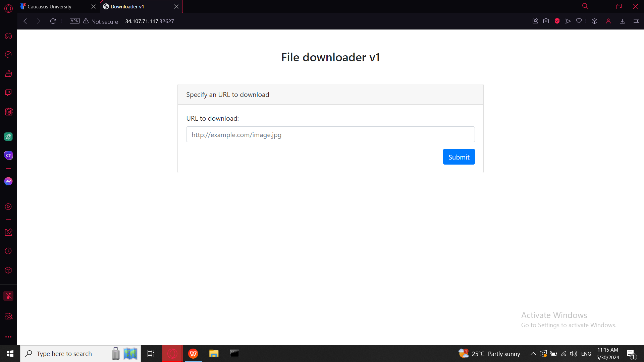

As always I started with discovering of page source

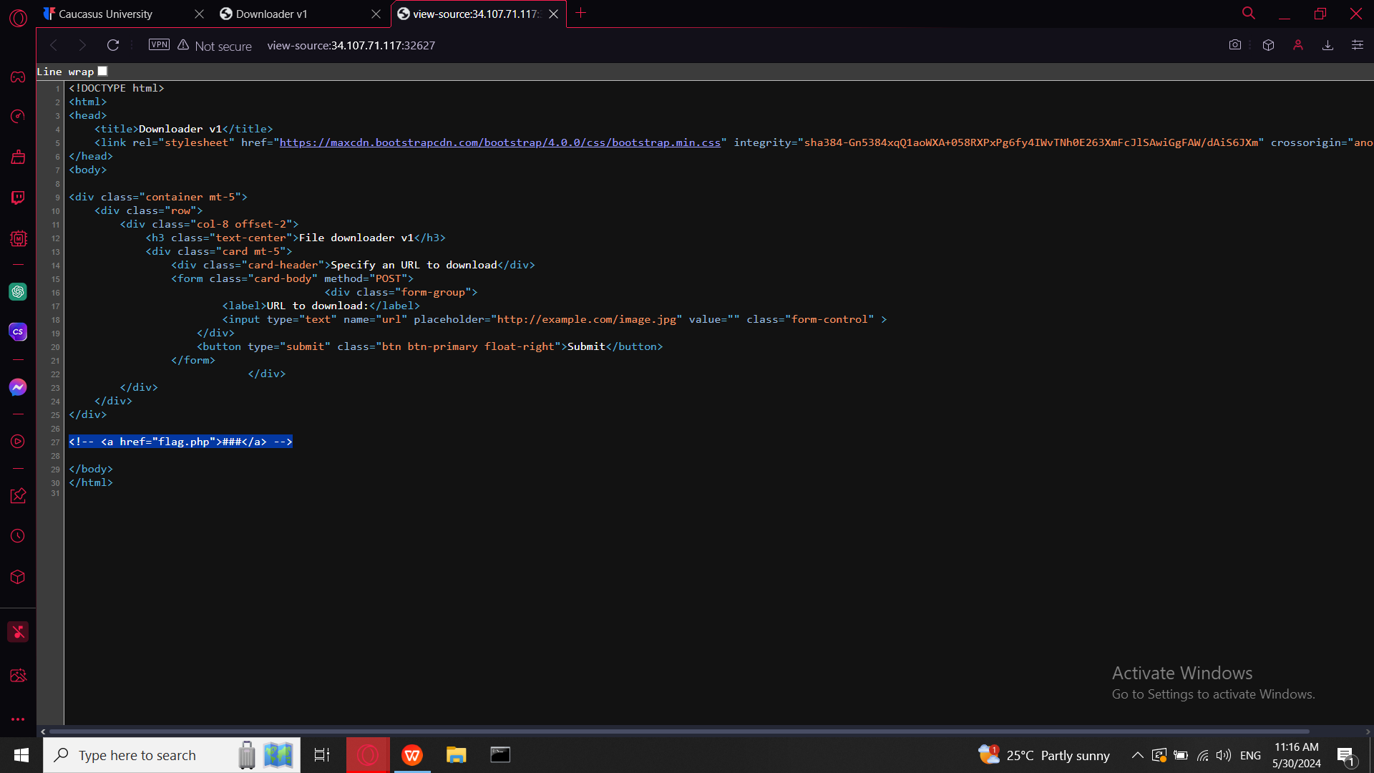

there I found interesting line where was mentioned flag.php this its what we ar looking for so I am going to use pipedream this is tool which provides custom endpoints where I will sent request with flag

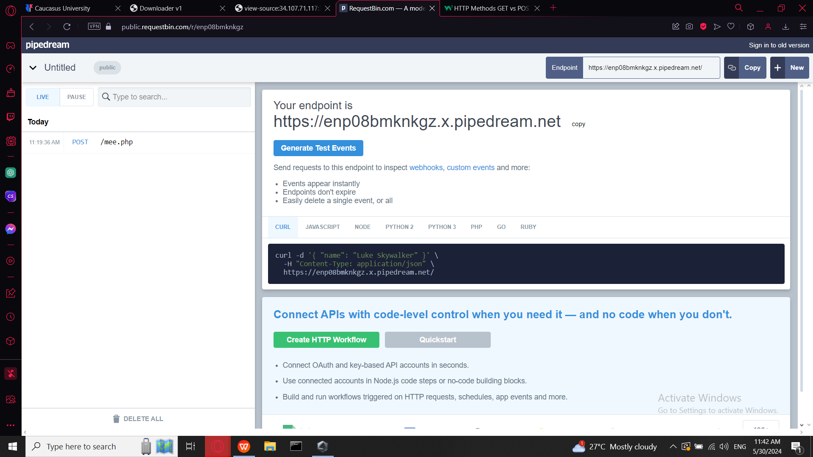

We just copy our end point url and paste it in sites input bar

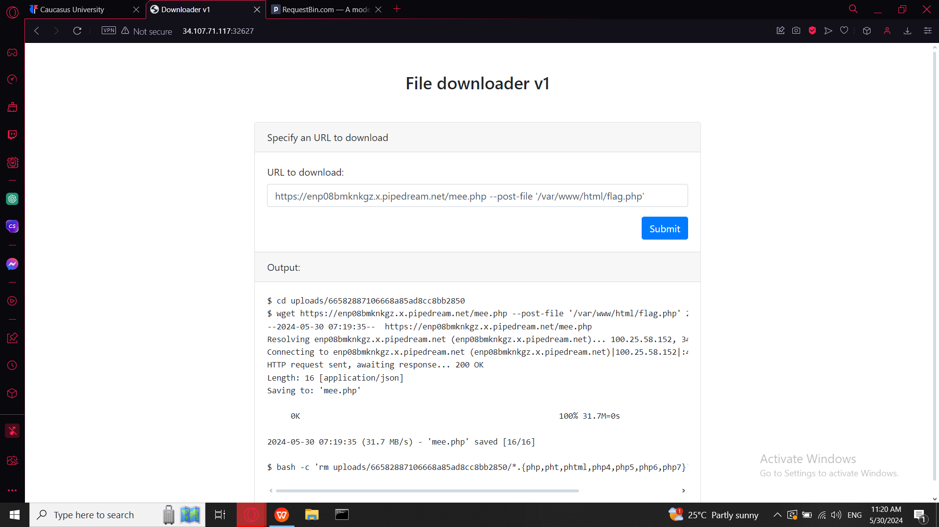

we have to use HTTP POST request for what --post-file is responsible in my command and then we add path were flag.php can be there is path breakdown

Var is root directory in linux were is saved frequently changed files-variables

WWW is directory which is location of web content

Html in this case is used as subdirectory where it is stored html and php files that will be served by the web server

And at the end flag.php is php file were should be stored our flag

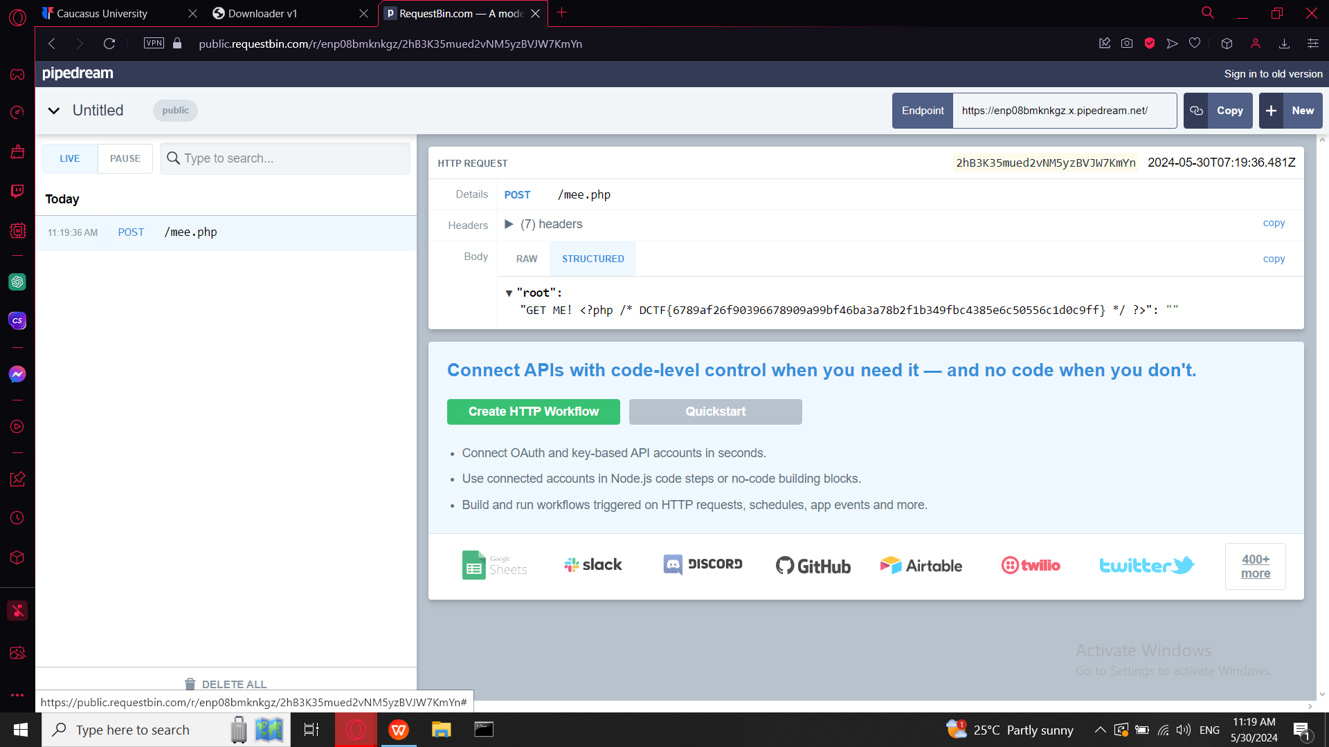

DCTF{6789af26f90396678909a99bf46ba3a78b2f1b349fbc4385e6c50556c1d0c9ff}